TranscribIA — Presentation file for the consultation of the Social and Economic Committee (CSE)
Localised edition v1.1 — 2026-10-17
The French text is authoritative. This edition covers France, Ireland, the Netherlands, Spain and Portugal. Language does not select the deployment country, parties or applicable law. Read the national annex at the end of this document according to the actual country and use.
Reference | CSE-TRANSCRIBIA-2026-01
Version | 1.0
Date | 2026-07-24
Editor | OHADJA
Classification | Public — standard document, adapted by each employer

Who is this document for?
This document presents the introduction of TranscribIA to employee representatives. Its references to the Comité social et économique (CSE) concern French law. For another country, local rules on representation, information, consultation or prior agreement must be identified according to applicable features, uses, workforce size and agreements. A translation does not automatically transpose the CSE's powers.
It is deliberately written in accessible language, without technical prerequisites. Its objective is to give you a clear and honest vision of what the tool does, what it does not do, and its possible consequences on working conditions.
Important note: This document is “off-the-shelf” media provided by the publisher. It describes the general possibilities of the tool. How your employer configures and actually uses TranscribIA is their responsibility and must be covered in the information they provide to you during the consultation.

1. Product Overview

1.1 What TranscribIA does
TranscribIA is software that helps transform an audio recording into text and then produce usable documents. Concretely, from an audio file (for example the recording of a meeting), the tool:
- automatically transcribes speech into written text;
- identifies changes in speaker (he distinguishes “a first person speaks”, then “a second person speaks”), in order to structure the text;
- writing assistance: at the request of a user, it can offer a summary, a draft report or minutes, a division into themes, a correction of the transcription;
- exports the result as documents (for example in Word format).
In summary: TranscribIA is a tool to help write reports. It saves time on a tedious task — listening, transcribing, formatting.
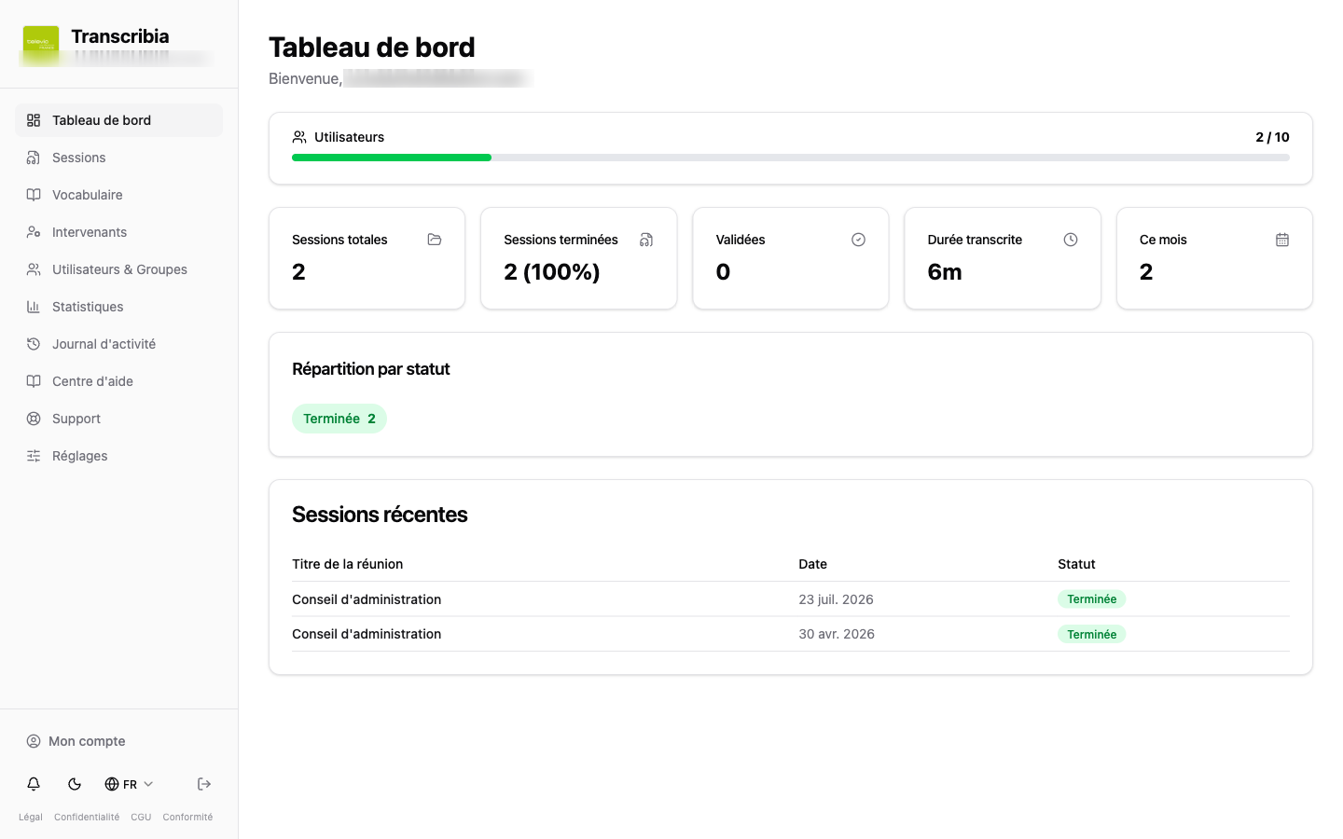
Figure 1 — Dashboard: overview of the organization's space (user quota, usage statistics, recent sessions; “Olivier Démo” demo account, test data).
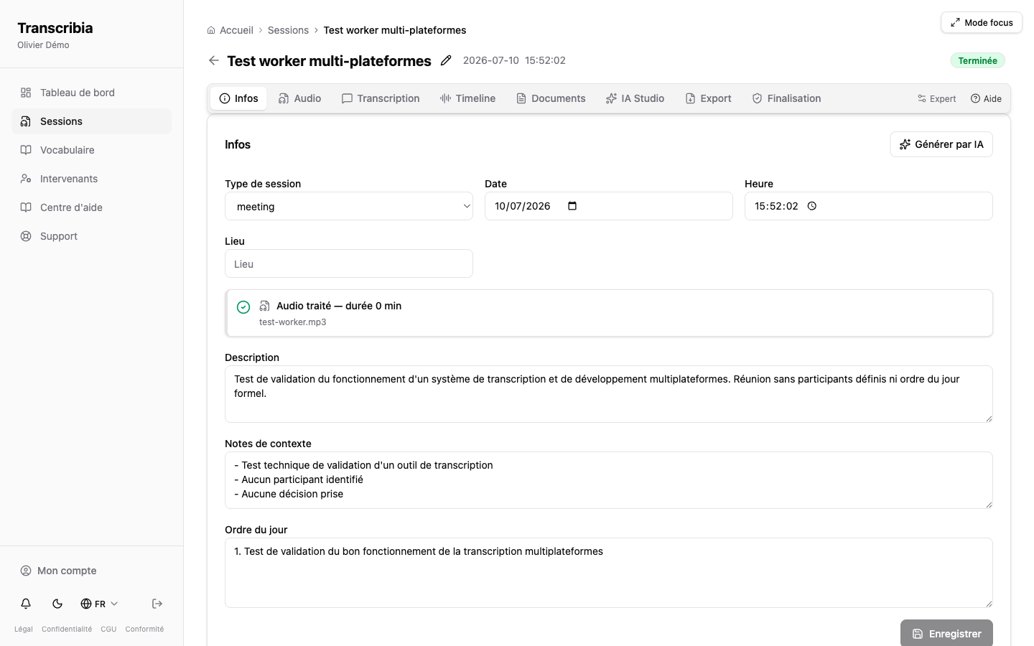
Figure 2 — Session sheet: context information (type, date, description, agenda) defined by the organization before transcription.

1.2 What TranscribIA does not do
For the avoidance of doubt, here is what the tool is not and does not do:
- It is not an employee monitoring tool. It does not “listen” continuously and does not record anything of itself: it only processes the audio files that the employer decides to entrust to it.
- It is not a personnel evaluation tool. It does not measure performance, does not rate speeches, does not compare people to each other.
- It does not make any automatic decision concerning a person (neither sanction, nor evaluation, nor classification).
- It does not automatically “recognize” voices to register people: the proposals it makes must always be validated by a human (see section 2).
Until a user has confirmed a name, speakers are displayed under neutral labels such as “Speaker 1”. These labels do not guarantee anonymity. Automated identification suggestions may be offered according to enabled features; human validation does not remove applicable data protection obligations.
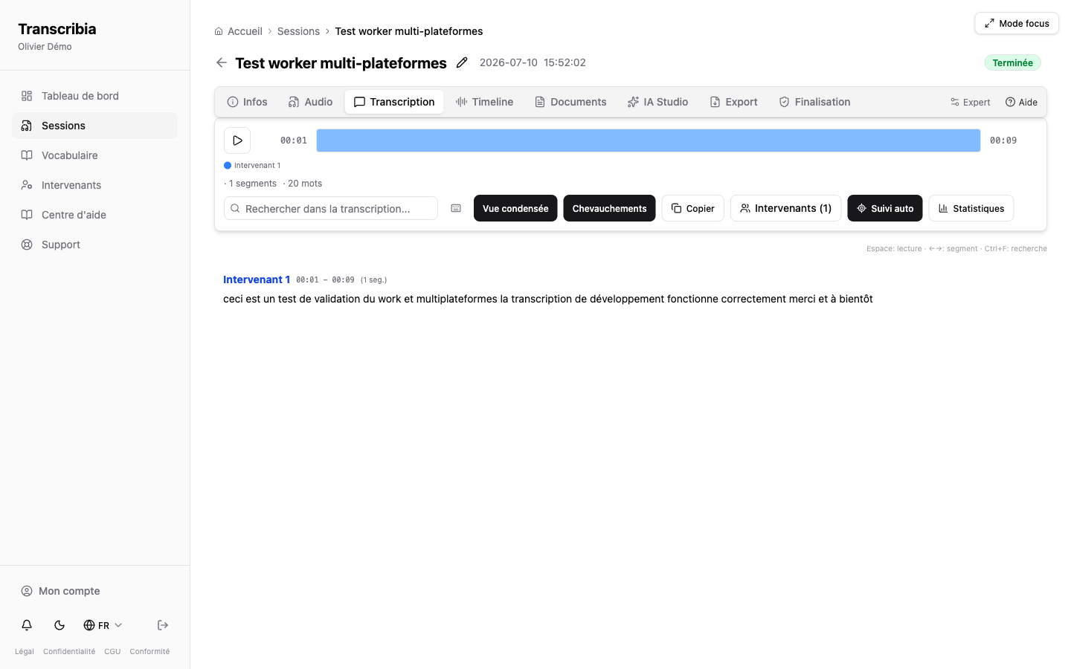
Figure 3 — Transcription tab: speakers are displayed under neutral labels until a person has confirmed their name. Automated comparison or suggestions may occur when the corresponding feature is enabled; labels do not guarantee anonymity.

2. Impact on activities and working conditions

2.1 A help tool, no control
The main benefit of TranscribIA is time savings in the production of meeting minutes. The transcription task, often long and unrewarding, is largely automated. The people responsible for writing focus on proofreading, validation and final formatting.
TranscribIA does not introduce a measure of individual productivity. It does not produce any indicator such as “speaking time per employee”, “number of interventions” or “contribution rating” intended to evaluate people.

2.2 The human keeps the hand
An essential characteristic of the tool: the suggestions produced by artificial intelligence are always subject to human validation.
- The summaries, reports and corrections proposed by the AI are drafts: an authorized user rereads them and decides what is retained.
- When the tool suggests associating a name with a voice (for example “this passage seems to correspond to Mrs So-and-so”), it is a simple suggestion: it is never retained without someone having confirmed it.
No decision concerning a person is therefore taken “by the machine”.

2.3 The role of the employer
The employer remains responsible for the use made of the tool. In particular, it belongs to him:
- decide which meetings are recorded and transcribed;
- to inform participants that a recording is being made and that it will be transcribed using this tool;
- define who has access to recordings and transcripts within the organization;
- to set data retention periods;
- to ensure compliance with applicable regulations (data protection, information of individuals, social dialogue).
The publisher (OHADJA) provides the tool and its technical guarantees; he has no knowledge of the meetings concerned or the people recorded, which only the employer determines.

3. Data processed and guaranteed

3.1 What data is processed
TranscribIA processes the data that the employer decides to entrust to it, mainly:
- audio recordings of meetings chosen by the employer;
- the resulting transcriptions;
- the names of the speakers, when a user enters them to make the report readable;
- possible preparatory documents (agenda, notes);
- technical operating data (who connected, when, what actions were carried out).
Only meetings decided by the employer are concerned. The tool does not capture anything outside this perimeter.

3.2 Information for participants
Before recording and transcription, the employer must clearly inform participants and verify lawfulness, necessity, proportionality, the lawful basis, any conditions concerning sensitive data and national recording rules. Mere information, acceptance of the software or lack of objection does not constitute general authorisation. Employee representatives' rights and applicable agreements must be respected before implementation.

3.3 Your rights (GDPR)
People whose data is processed have the rights provided by the General Data Protection Regulation (GDPR), including access, rectification, erasure, restriction and objection. These rights are exercised through the employer, which is the controller. The tool provides technical means enabling the employer to respond (search, export, deletion and correction of entered information).

3.4 Storage periods
The retention periods for recordings, transcriptions and documents can be configured by the organization. It is the employer who sets them, according to his needs and the regulations. The CSE may ask to know the durations chosen.

3.5 Speaker recognition: what you need to understand
This is a point often a source of concern; here is the technical reality, presented honestly.
- Distinguishing speakers (diarisation): the tool separates passages using labels such as “Speaker 1”, “Speaker 2”. These labels remain personal data when a participant is identifiable from the audio or context. The absence of a retained voiceprint is a data minimisation safeguard but does not suffice to exclude biometric classification. This depends on the technical means and purpose of unique identification. A user can subsequently assign a name to the labels.
- Voice correlation (optional feature): the tool can compare voice characteristics across meetings to suggest name matches, subject to human validation. This feature is disabled by default. Before activation, the employer must establish its necessity, lawful basis, an applicable Article 9 condition where unique identification is intended, and national requirements concerning employment and biometrics. The dedicated DPIA and contractual addendum are required but do not, by themselves, authorise the processing. Temporary representations are deleted after processing within the documented technical scope.
The publisher undertakes to never introduce permanent automatic voice recognition (creation of a voiceprint database) without an explicit contractual update accepted in advance by the organization, with at least 60 days' notice.

4. Safety conditions (accessible summary)
Without going into technical detail, here are the main security guarantees surrounding the tool:
- Hosting in France or at home: in service mode, the data is hosted on a server located in France, with backups kept in the European Union. An “on-premises” variant allows everything to be hosted within your organization’s infrastructure, without dependence on an external service.
- Encryption: exchanges are encrypted (HTTPS protocol) and backups are encrypted before being outsourced.
- Access control: each user has a role and rights limited to what is necessary for them; enhanced authentication (double factor) may be required; Sensitive transactions require additional confirmation.
- Logging: important actions (connections, creations, modifications, deletions, exports) are traced, which allows you to know who did what and to detect possible abuse.
- Anti-virus control of submitted files and data isolation between client organizations.
In the event of a personal data breach, OHADJA informs the employer without undue delay. The employer assesses notification to the competent supervisory authority, where feasible within 72 hours of awareness when required, and communication to individuals in the event of high risk under Articles 33 and 34. The CNIL is the French authority; the applicable authority does not depend on this document's language.

5. Points of vigilance recommended to the CSE and good practices
The CSE can usefully focus its attention on the following points, which relate to implementation by the employer:
- Usage charter: recommend the establishment of a charter governing the use of the tool (which meetings, for what purpose, who accesses the reports, retention periods).
- Prior information of participants: ensure that any registered person is clearly informed in advance of the registration and its processing by the tool.
- Limited purpose: ensure that the tool is used for writing reports, and not for monitoring or evaluating employees.
- Case of external visitors: pay particular attention to external people present at the meeting (speakers, service providers, users), who must also be informed.
- Sensitive meetings: consider excluding certain meetings (staff representation, individual situations, confidential subjects) from the scope of the tool.
- Rights of individuals: ensure that the methods for exercising rights (access, rectification, erasure) are known and effective.
- Shelf life: request the durations chosen and check that they are proportionate.

6. Frequently Asked Questions (FAQ)
1. Is my voice stored permanently? The transcription works on the audio file of the meeting, kept for the duration set by the employer. On the other hand, the tool does not constitute a permanent “voice print”: the calculations used to distinguish speakers are temporary and erased at the end of processing.
2. Can I be automatically identified by my voice? Voice correlation is disabled by default. Diarisation uses neutral labels (“Speaker 1, 2, 3”), which do not guarantee anonymity when the person is identifiable in the recording. A human may assign names. Optional voice comparison only produces suggestions requiring validation and requires a prior lawfulness assessment, including Articles 6 and 9 where biometric identification is involved.
3. Can my manager assess my contributions using the tool? The product is presented as drafting assistance, rather than for individual assessment. A recording or transcript may nevertheless enable monitoring; the employer must prevent misuse beyond the stated purpose. Any monitoring proposal requires a separate legal assessment and respect for representatives' rights; some uses are prohibited by national law, even with information or agreement.
4. Does the tool record meetings constantly? No. He doesn't capture anything about himself. It only processes audio files that the employer decides to entrust to it, for the meetings it has chosen.
5. Does artificial intelligence decide anything about me? No. The productions of AI (summaries, reports, identification suggestions) are proposals. Someone rereads them and validates. No automatic decisions are made on individuals.
6. Who has access to my recordings and transcriptions? Access is defined by the employer, based on limited roles and rights. The tool publisher does not have access to your organization's meeting content as part of normal operation.
7. Can my data go abroad? Location depends on the mode and options actually enabled. SaaS provides for hosting in France and backups in France/the EU, but some AI fallback paths or GPU resources may involve processing outside the EEA, depending on configuration. The employer must verify the flow mapping, subprocessors and a valid mechanism before any transfer; the “strict EU” profile must be confirmed and enabled if no transfers outside the EEA are required. On-premise excludes external flows only within its documented isolated scope.
8. How long is my data kept? The durations are configurable and set by the employer. The CSE may request details.
9. Can I request the erasure of my data? Yes, by exercising your rights with the employer (controller). The tool provides the technical means to search, export and delete the data concerned, and to establish proof of deletion.
10. What happens in the event of a data leak? OHADJA alerts the employer without undue delay after becoming aware of a breach. The employer assesses the legally required notifications to the competent supervisory authority and, where there is a high risk, to affected individuals. The CNIL is the French authority, without automatically being competent for every customer.

Appendix — Interface Overview
The captures below come from a demo account (“Olivier Démo”) supplied with innocuous test data.
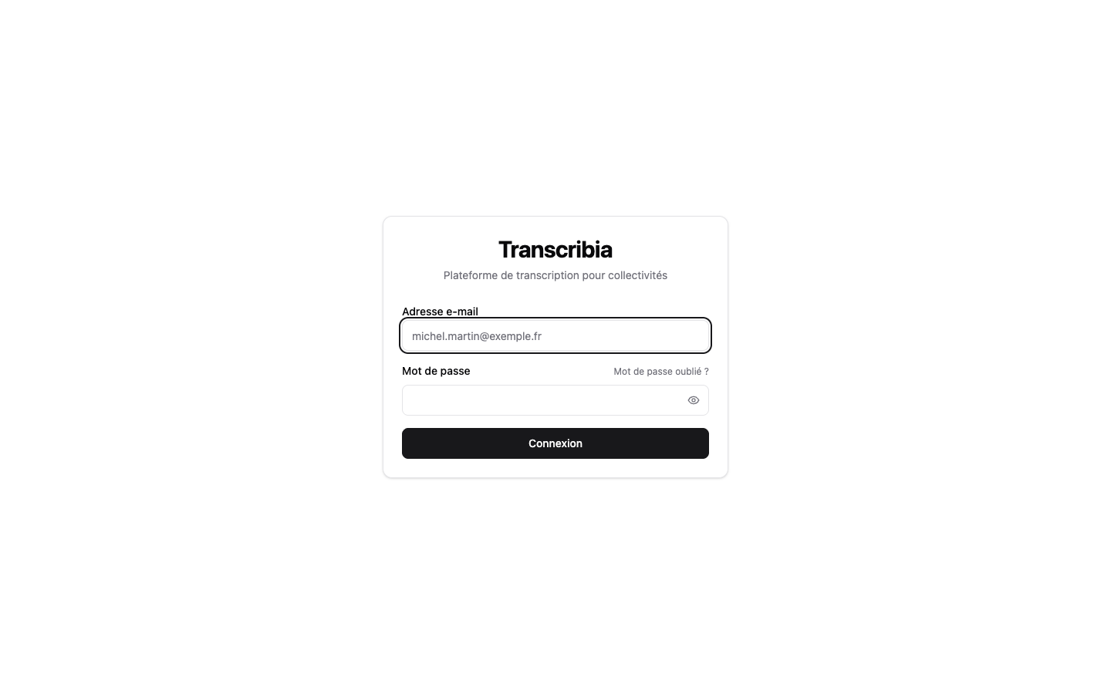
Figure 4 — Login screen: access is personal and password protected (double-factor enhanced authentication may be required).
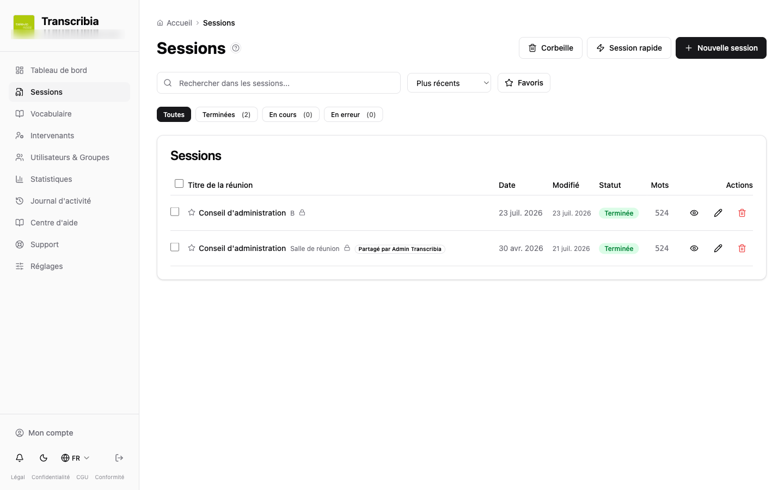
Figure 5 — List of sessions: search, filters by status, trash and sharing; only meetings that the organization has decided to process are shown.

This document is an “off-the-shelf” information medium prepared by OHADJA. It does not replace the information that your employer must communicate as part of the CSE consultation, nor a legal opinion. The concrete implementation arrangements are up to the employer, controller.

Annex on national deployment rules

Scope of this annex
This edition covers the European Union GDPR framework and the deployment considerations below for France, Ireland, the Netherlands, Spain and Portugal. The notices must be read according to the Customer’s actual country and use, regardless of the document’s language. They supplement the project documents without automatically changing the parties’ identities, the chosen French governing law or the designated courts. Applicable mandatory rules remain reserved. French national references in the main document remain identified as such; they do not constitute foreign equivalents.

European framework to document before commissioning
The Customer must determine the purpose, necessity, proportionality and lawful basis of every recording and processing operation; inform individuals before collection; define recipients, retention periods and arrangements for exercising rights; and conclude an Article 28-compliant agreement for operations entrusted to a processor. Information, consultation or human validation alone does not make processing lawful. Employee consent must be considered cautiously given the imbalance with the employer.
If special categories of data are processed, an applicable Article 9 condition must be identified in addition to the Article 6 basis. Voice comparison intended for unique identification must be assessed in terms of biometrics, even without a persistent template. An impact assessment must be conducted before processing likely to result in a high risk, and the rules on prior consultation of the authority remain applicable where Article 36 conditions are met. Neither local hosting nor an addendum removes the need for this assessment.
The competent authority depends on GDPR rules, particularly for cross-border processing; it does not depend on the selected language. The processor alerts the Customer without undue delay. The controller notifies the competent authority under Article 33 conditions, where feasible within 72 hours of becoming aware of a breach, unless it is unlikely to result in a risk to rights and freedoms. Communication to individuals is subject to Article 34 conditions.
European sources https://eur-lex.europa.eu/eli/reg/2016/679/oj and https://www.edpb.europa.eu/documents/guideline/guidelines-052020-on-consent-under-regulation-2016679_en

France
For deployment in France, determine employee information and prior CSE consultation obligations according to the system, workforce size and applicable legal scope. The French Labour Code covers, in particular, techniques enabling activity monitoring, even if the product is presented as drafting assistance. Information and consultation do not replace the assessment of lawfulness, necessity and proportionality, or rules concerning private conversations, sensitive data and confidentiality. The CNIL is the national authority, subject to GDPR jurisdiction rules.
French sources Labour Code Articles L1222-4 and L2312-38 https://www.legifrance.gouv.fr/codes/article_lc/LEGIARTI000006900861 and https://www.legifrance.gouv.fr/codes/section_lc/LEGITEXT000006072050/LEGISCTA000035610273/

Ireland
For deployment in Ireland, apply the GDPR and national framework; document the lawful basis and inform participants before recording. Examine employee information and consultation obligations according to scope, workforce size, collective agreements and existing arrangements. The Irish system is distinct from the French CSE and does not create an identical consultation requirement for every employer. The Data Protection Commission is the national authority, subject to cross-border jurisdiction rules.
Irish sources https://www.dataprotection.ie/en/dpc-guidance/video-recording and Employees (Provision of Information and Consultation) Act 2006 https://www.irishstatutebook.ie/eli/2006/act/9/enacted/en/print

The Netherlands
For deployment in the Netherlands, examine the powers of the ondernemingsraad or OR. A system capable of monitoring attendance, behaviour or performance may fall within its right of prior approval under the Wet op de ondernemingsraden, even if it is not yet used for that purpose. OR approval replaces neither the lawful basis of processing nor the conditions applicable to biometrics and sensitive data. The Autoriteit Persoonsgegevens is the national authority, subject to GDPR jurisdiction rules.
Dutch source Autoriteit Persoonsgegevens https://autoriteitpersoonsgegevens.nl/en/themes/employment-and-benefits/works-council/the-works-council-and-staff-tracking-systems

Spain
For deployment in Spain, distinguish meeting transcription from the use of audio surveillance systems. Within the scope of Article 89 of Ley Orgánica 3/2018, workplace sound recording is strictly limited to certain security risks, with proportionality, minimal intervention and safeguards; rest areas are protected. Examine representatives’ information and consultation rights and applicable agreements. These provisions must not be extended without assessment to every occasional meeting, and participants’ agreement is not general authorisation. Identify the AEPD or competent regional authority according to the processing.
Spanish sources Ley Orgánica 3/2018 Article 89 https://www.boe.es/buscar/act.php?id=BOE-A-2018-16673#a89 and Estatuto de los Trabajadores Article 64 https://www.boe.es/buscar/act.php?id=BOE-A-2015-11430#a64

Portugal
For deployment in Portugal, examine the Código do Trabalho, Lei 58/2019 and rules applicable to the specific system. Remote surveillance intended to monitor professional performance is prohibited. Sound capture within a video surveillance system is subject to specific restrictions; this means neither that every meeting recording is prohibited nor that it is always authorised. Determine obligations towards workers and their representatives before commissioning. The Comissão Nacional de Proteção de Dados is the national authority, subject to GDPR jurisdiction rules.
Portuguese sources Código do Trabalho Articles 20 and 21 https://diariodarepublica.pt/dr/legislacao-consolidada/lei/2009-34546475-211441911 and CNPD https://www.cnpd.pt/organizacoes/areas-tematicas/videovigilancia/

French frameworks and project commitments
The terms CSE, CGCT, HDS, SecNumCloud, ANSSI and RGAA refer to French institutions, rules or frameworks. They establish neither TranscribIA certification nor automatic compliance with a foreign framework. Amounts and payment mechanisms in the terms of sale, including the reference to the French Commercial Code, must be considered together with the chosen law, the Customer’s status and applicable mandatory rules; they must not be presented as transpositions of each national law. Arrangements applicable to public procurement, consumers and regulated sectors must be specified separately where relevant.
Before signature, complete and verify the project annexes concerning the parties, SaaS or on-premise configuration, processing and access locations, subprocessors, transfers, actual security measures, retention and service levels. This annex does not establish that a technical measure is already deployed and does not replace agreed specific commitments. British and Belgian regimes and other countries are not covered by these national notices; they require separate adaptation.
Interface screenshots and examples from the application may remain in French. Explanatory text and document captions are translated; commands, filenames, technical identifiers and document references must be preserved exactly.

History of this edition
1.1 — 2026-10-17
Multilingual edition and document corrections. Earlier versions and their dates are retained. The French text is authoritative; translations aid reading and do not change the parties or applicable law.

